**Assignment MT1-2019-1**

**Section =1**

(Based on lecture notes)

Note: 1) Use the notations used in the class whenever necessary

2) Assume Binary mixture

Q.1) Define

1. Mass average velocity
2. Molar average velocity
3. n , i and j
4. N,I and J

Q.2) Write the statement of Fick’s Law and Express in the mathematical terms. Express Fick’s law in terms of other flux.

Q.3) What is diffusivity? What are the factors which affects the diffusivity?

What is the unit of diffusivity?

Q.4) Proof DAB=DBA  (For ideal gas)

Q.5) State Ernst Einstein Equation.

Q.6) Write the equations for following correlations to estimate gas phase diffusivity

1. Chapman - Enskog correlation based on KT
2. Fuller correlation

Q.7) Write the equations for following correlations to estimate liquid phase diffusivity

1. Stokes Einstein equation
2. Wilke Chang Euqation

Q.8)Provide the relationship to estimate the gas mixture diffusivity from binary diffusivity

Q.9) Describe (1) Knudsen (pore) diffusivity (2) Knudsen number (3) values of Knudsen number for Knudsen diffusivity to occur.

Q.10) What is surface diffusivity?

Section-2

(Based on the work out problems in the text book)

1. From book: Principle of mass transfer by B.K.Dutta Ex.2.1 Page no.10

**Section=3**

(Unsolved problems)

1. The composition of air is often given in terms of only the two principal species in the gas mixture

oxygen, O2, yo2 = 0:21

nitrogen, N2, yN2 = 0:79

Determine the mass fraction of both oxygen and nitrogen and the mean molecular weight of the air when it is maintained at 250C (298 K) and 1 atm (1.013×105 Pa). The molecular weight of oxygen is 0.032 kg/mol and of nitrogen is 0.028 kg/mol.

1. Evaluate the diffusion coefficient of carbon dioxide in air at 200C and atmospheric pressure. ΩD = 1.047

The values of s and e/k are,

Ϭ in A0 εA, in K

Carbon dioxide 3.996 190

Air 3.617 97

1. Re-evaluate the diffusion coefficient of carbon dioxide in air at 208C and atmospheric pressure using the Fuller, Schettler, and Giddings equation and compare the new value with the one reported in example 2.
2. In the chemical vapor deposition of silane (SiH4) on a silicon wafer, a process gas stream rich in an inert nitrogen (N2) carrier gas has the following composition:

ySIH4 = 0.0075, yH2 = 0.015, yN2 = 0.9775

The gas mixture is maintained at 900 K and 100 Pa total system pressure. Determine the diffusivity of silane through the gas mixture. The Lennard–Jones constants for silane are εA /k = 207.6K and ϬA = 4.08A0



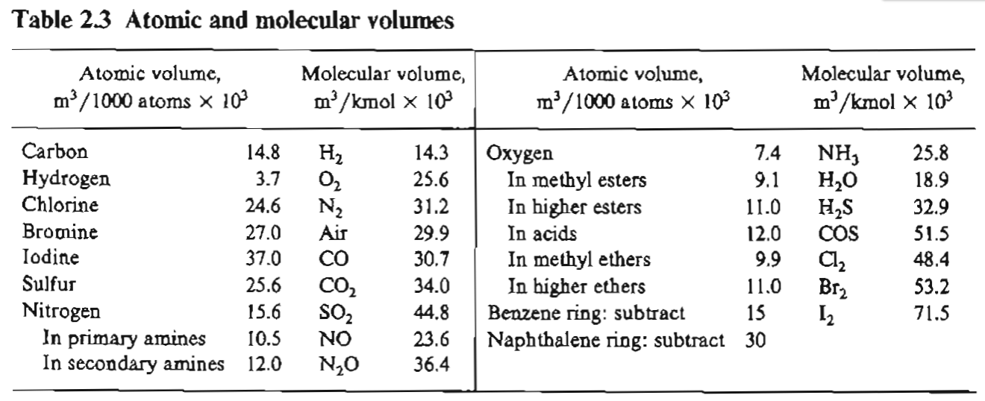

the remaining parameters to be used are

T = 283K

ΦB for water = 2.26, viscosity can be taken as that for water 0.001005 Kg/m.s

And MB for water = 18

1. One step in the manufacture of optical fibers is the chemical vapour deposition of silane (SiH4) on the inside surface of a hollow glass fiber to form a very thin cladding of solid silicon by the reaction

SiH4(g) → Si(s) + 2H2(g)

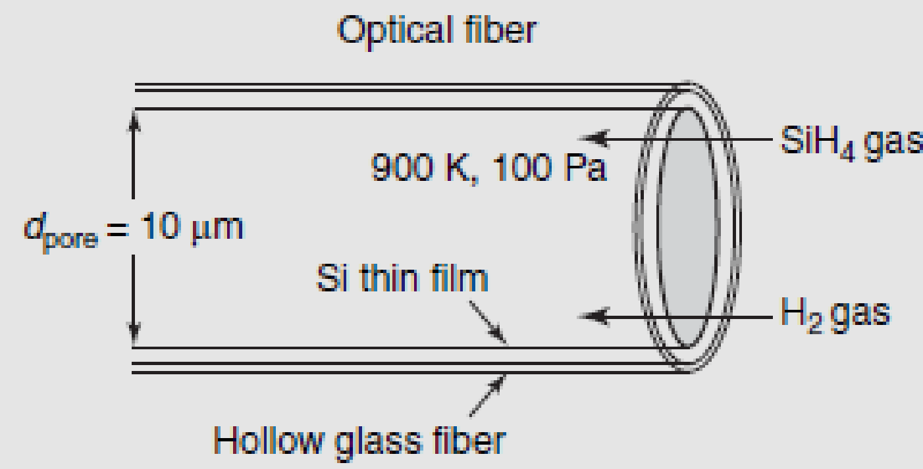

as shown in Figure 24.4. Typically, the process is carried out at high temperature and very low total system pressure. Optical fibers for high bandwidth data transmission have very small inner pore diameters, typically less than 20µm. If the inner diameter of the Si-coated hollow glass fiber is 10µm, assess the importance of Knudsen diffusion for SiH4 inside the fiber lumen at 900 K and 100 Pa (0.1 kPa) total system pressure. Silane is diluted to 1.0 mol % in the inert carrier gas helium (He). The binary gas phase diffusivity of silane in helium at 250C (298 K) and 1.0 atm (101.3 kPa) total system pressure is 0.571 cm2/s, with ϭSiH4 = 4.08A˚ and εSiH4 /k =207.6K. The molecular weight of silane is 32 g/mol.

7) Highly purified tetrachlorosilane (SiCl4) gas is reacted with hydrogen gas (H2) to produce electronic-grade polycrystalline silicon at 800 0C and 1.5 *105 Pa according to the equction: 

There are concerns that the reaction experiences diffusional limitations at the growing Si solid surface. Estimate the molecular diffusion coefficient for (a) SiCl4 in H2 and (b) SiCl4 in a gas phase mixture containing 40 mol% SiCl4, 40mol% H2, and 20 mol % HCl. The Lennard–Jones parameters for SiCl4 (species A) are :



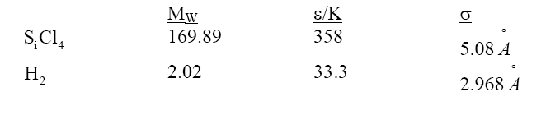

And, 

8) An absorption tower has been proposed to remove selectively two pollutants, hydrogen sulfide (H2S) and sulphur dioxide (SO2), from an exhaust gas stream containing :

H2S 3vol %

SO2 5 vol %

N2 92 vol %

Estimate the diffusivity of hydrogen sulfide in the gas mixture at 350 K and 1.013*105 Pa. The critical temperature (TC) of H2S is 373.2 K and the critical volume (VC) of H2S is 98.5 cm3/mol.

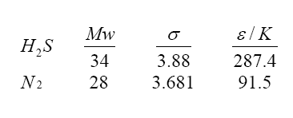

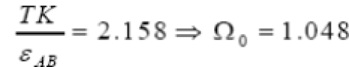

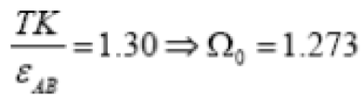

9) Estimate the liquid diffusivity of the following solutes that are transferred through dilute solution.

N-butanol in water at 288 K. VC4H9OH=103.6





10) Researchers are proposing the development of a ‘‘nanochannel reactor’’ for steam reforming of methane (CH4) to fuelcell hydrogen gas to power microscale devices.

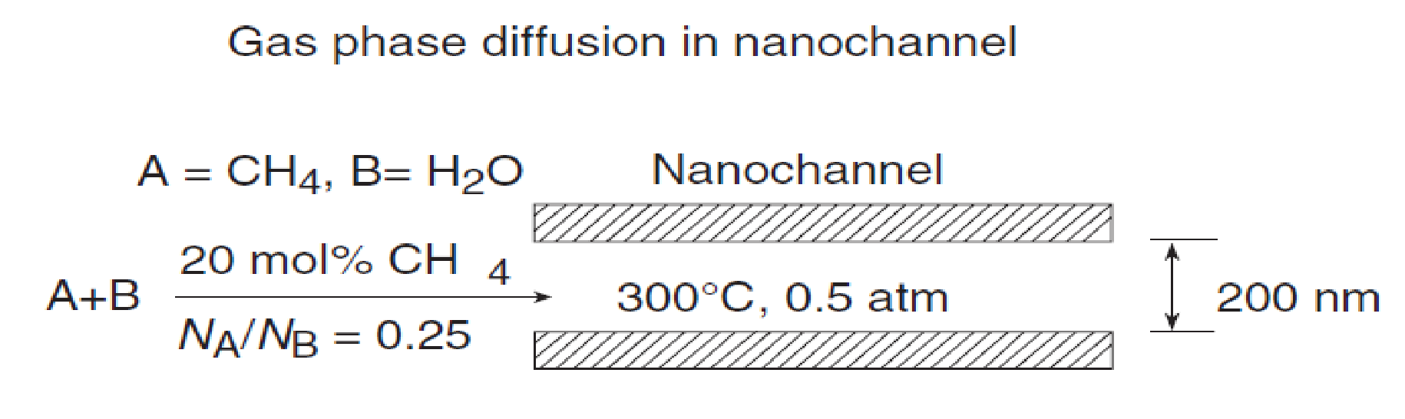

As each channel diameter is so small, the gas flow is likely to be very small within a given channel. Hence, gas diffusion processes may play a role in the operation of this device, particularly during the mixing and heating steps. We are specifically interested in evaluating the effective diffusion coefficient of methane gas (species A , MA = 16g/g.mol) in water vapor (species B, MB=18 g/g.mol) at 300 0C and 0.5 atm total system pressure. The diameter of the channel is 200 nm (109 nm=10m). A feed gas containing 20 mol % CH4 in water vapor is fed to the nanochannel with a flux ratio NA/NB=0.25. What is effective diffusion coefficient of CH4 in the nanochannel at the feed gas conditions? Is Knudsen diffusion important?

